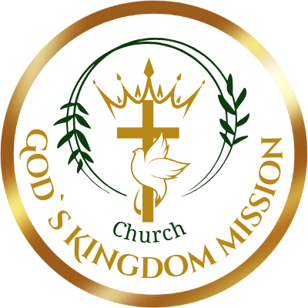

CONSTITUTION OF
Church “God`s Kingdom Mission”- Draudze “Dieva Valstības Misija”

NAME AND OBJECTIVES:
  - The official name of the organization shall be "God`s Kingdom Mission" in English and "Dieva Valstības Misija" in Latvian (referred to as "the organisation"). Both names may be used interchangeably for community needs and information distribution.

OBJECTIVES OF THE ORGANIZATION:
  - The objectives of the organization shall be:
  - To provide a place of worship for the Latvian community and others, fostering spiritual growth, fellowship, and the practice of Christian faith.
  - To promote religious education and spiritual development, through teaching, Bible study, mentorship, workshops, and other forms of instruction consistent with Christian values.
  - To engage in charitable activities for the benefit of the Latvian community residing in the UK, including children, youth, families, and elderly members.
  - To advance the spiritual well-being of the Latvian community, their family members, and other Christian communities, both locally in the UK and internationally, guided by the organization’s Christian principles and beliefs.
  - To actively participate in mission and outreach programs, including in Latvia and Pakistan, aimed at providing spiritual guidance, supporting education, alleviating poverty, and fostering sustainable community development. This may involve partnerships with reputable organizations, fundraising, and direct involvement in projects that enhance the well-being of communities served.
  - To live out the gospel by extending love, compassion, and practical support to those in need, locally in the UK and internationally, as a tangible expression of faith in Jesus Christ.

MEMBERSHIP:
  - Membership is open to individuals who share the beliefs and values of “the organization”.
  - Members shall be entitled to participate in the decision-making process of the church, including attending meetings and voting.
  - The conditions for membership, including any fees or obligations, shall be determined by the leadership team.

LEADERSHIP:
  - The organizational affairs shall be overseen by a leadership team, including the Pastor, “the organisation” Administrator, and additional ministry leaders responsible for various support areas.
  - The leadership team shall be elected by the members and shall serve for a term of 2 years.
  - The leadership team shall be responsible for the spiritual guidance, administration, and overall well-being of “the organisation”.

MEETINGS:
  - Regular meetings of “the organisation” shall be held yearly.
  - Regular meetings of the Leadership team shall be held monthly.
  - Meetings can be held electronically or virtually through special group video calls. Special meetings may be called by the leadership team or upon the written request of 50% of the members. Decisions shall be made by a 50% majority vote of the members present at a meeting.

- FINANCIAL MANAGEMENT:
  - The church shall maintain accurate financial records and operate within a budget approved by the membership.
  - All funds shall be used to further the objectives of "the organisation" and for no other purpose.
  - An independent financial review shall be conducted annually.

- AMENDMENTS:
  - This constitution may be amended by a 50 % majority vote of the members present at a meeting, provided that notice of the proposed amendment has been given in advance.

- DISSOLUTION:
  - In the event of the dissolution of "the organization' any remaining assets shall be distributed with the selection of the recipient left open for a future vote.

